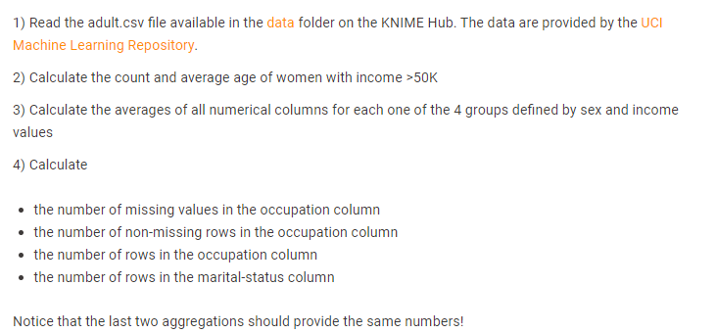

- Read the adult.csv file
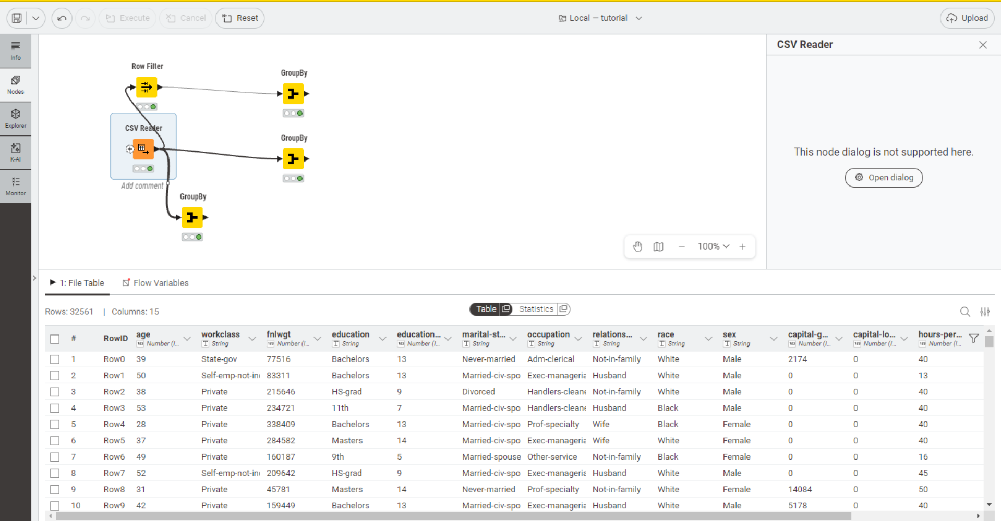

- A) Filter Female and Income >50k using Row Filter
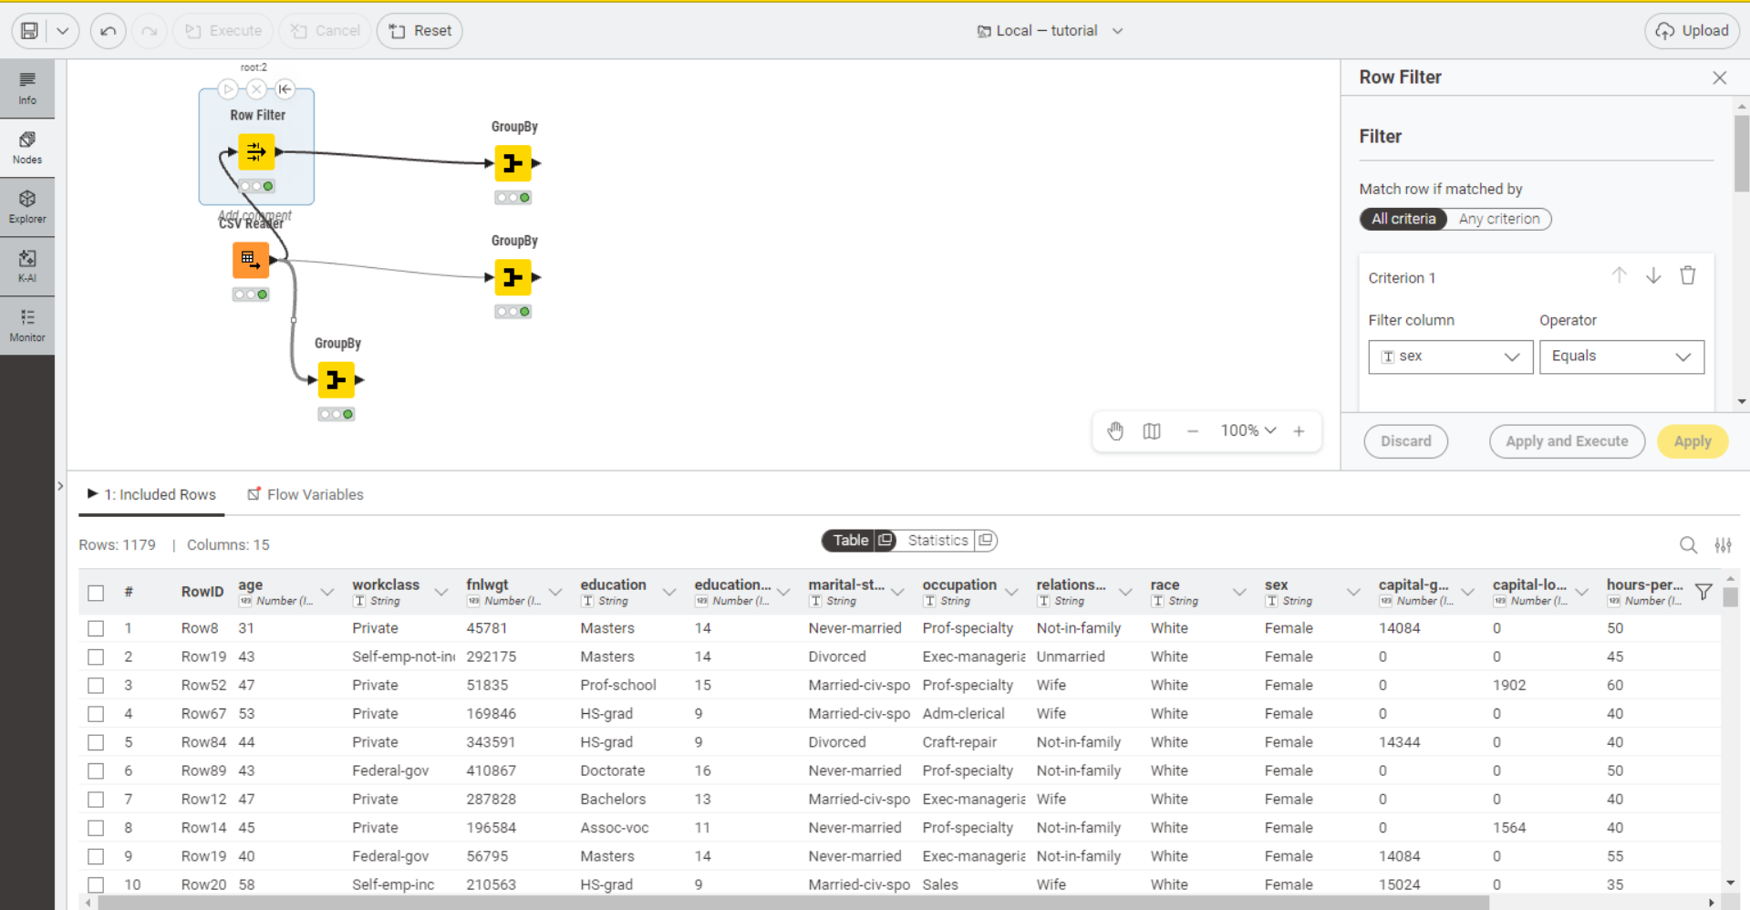

- B) Calculate the Count and Average age of women with income >50k
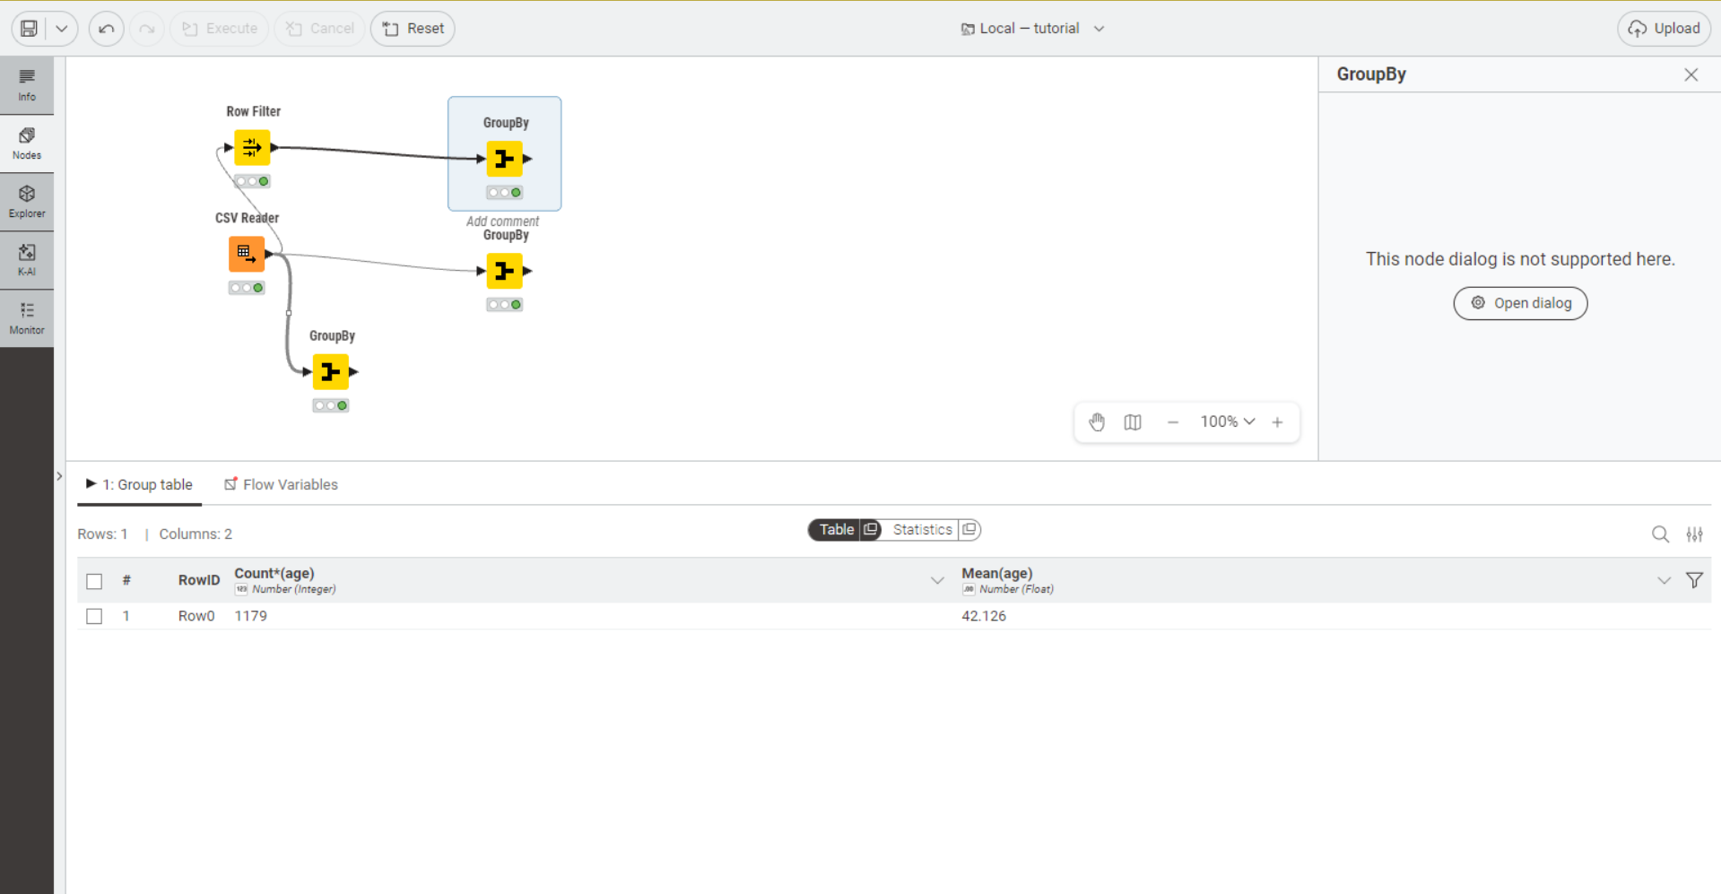

- Calculate the averages of all numerical columns for each one of the 4 groups defined by sex and income value
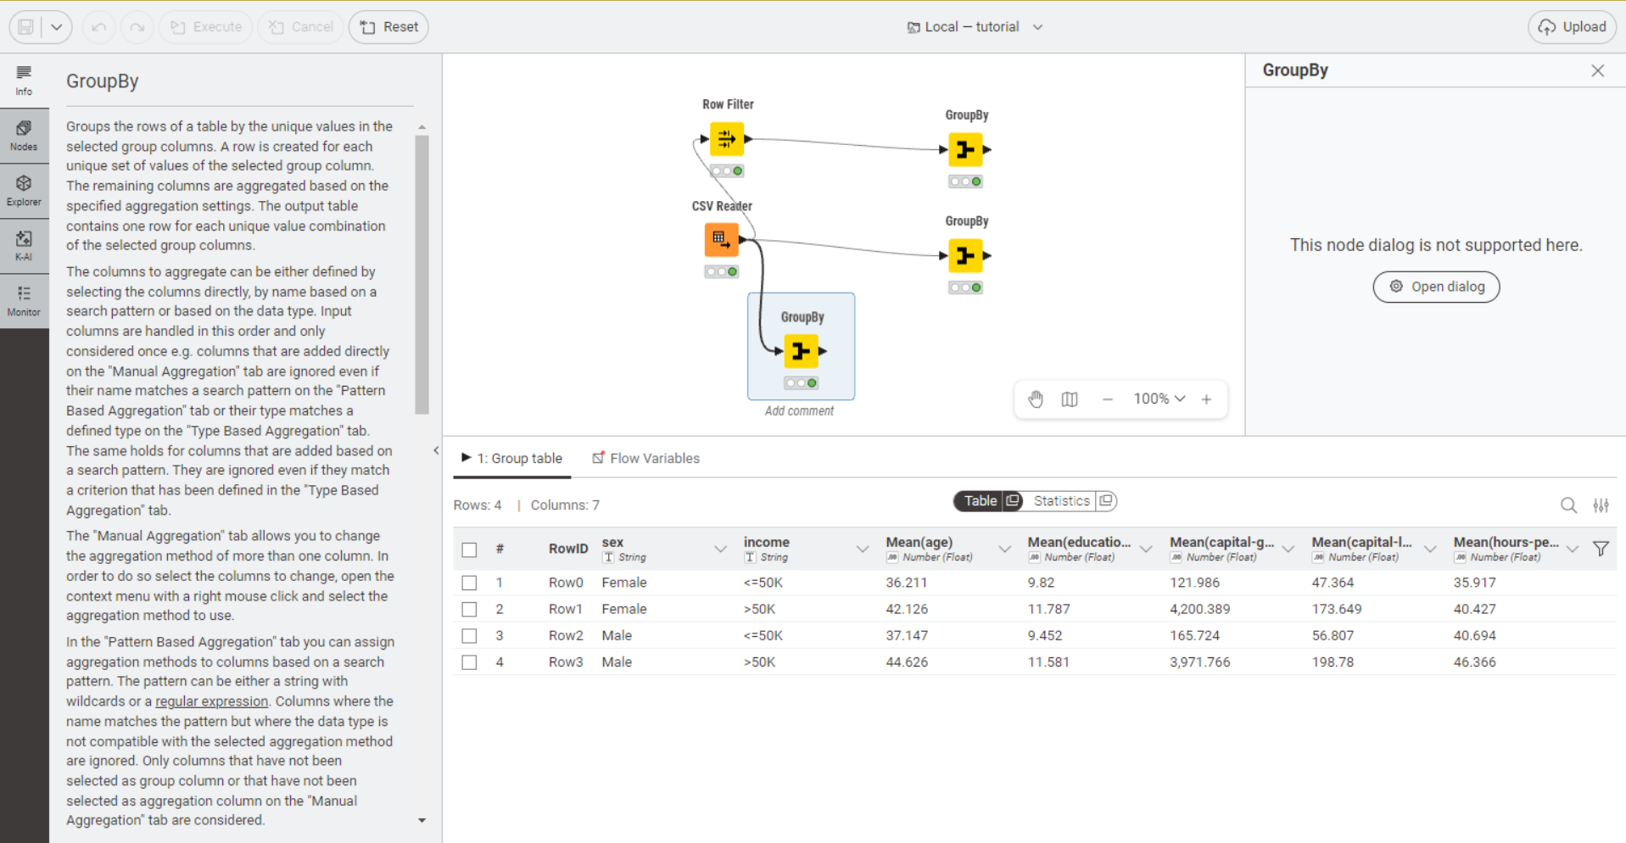

- Calculate:
- the number of missing values in the occupation column
- the number of non-missing rows in the occupation column
- the number of rows in the occupation column
- the number of rows in the marital-status column
